Using Sitemaps with Blueprint
Ian Davis, May 2009

Introduction
Sitemaps are files that are stored on a web server, and help search engines discover the content of your site without having to rely only on their ability to crawl and parse your web pages. While HTML-only pages are generally easy for a search engine to parse, if, for example, your home page makes extensive use of Flash and/or JavaScript, it may be very hard for them to successfully find links to follow to allow them to discover your site. This can obviously have a detrimental effect on the Search Engine Optimization of your site.
‘Sitemaps’ are not an official standard, but they enjoy support from Google, Yahoo!, MSN and many other search engines.
The sitemap files themselves are simple XML documents that contain links (and some additional data) to the pages of your site. A simple entry in a sitemap.xml file would look something like…
<url>
<loc>http://www.mysite.com/ondemand/index.jsp</loc>
<changefreq>weekly</changefreq>
<priority>1.0</priority>
</url>

…where ‘changefreq’ gives the search engine an idea of the volatility of your content for that page, and ‘priority’ is a 0.0 to 1.0 value indicating that importance you place on the content of that page in relation to other content on your site. There are other properties, and more information can be found at http://www.sitemaps.org/protocol.php.
If desired, a site may contain multiple sitemaps located in different directories. This can help manageability, or on very large sites, keep each individual sitemap within the maximum file size (10 Mb). When a sitemap is placed into a directory lower that the doc root, it may only contain links to that directory or its sub directories.
When multiple sitemaps are used by a site, they should all be referenced by a Sitemap Index file, which would look something like…
<?xml version="1.0" encoding="UTF-8"?>
<sitemapindex xmlns="http://www.sitemaps.org/schemas/sitemap/0.9">
<sitemap>
<loc>http://www.mysite.com/sitemap1.xml</loc>
</sitemap>
<sitemap>
<loc>http://www.mysite.com/sitemap2.xml</loc>
</sitemap>
</sitemapindex>

Solution Detail
This solution addresses the use of sitemaps on a ATG Commerce site.
The sitemap.jsp File
The sitemap.jsp file encapsulates all of the functionality to render the necessary Site Index and Site Map files for the site. It should be placed in the context root directory of the Web Application (the .war folder).
When called with no parameters, sitemap.jsp renders a Site Index which references URL which represent a set of Site Maps which expose the pages of the site. You will see that, when rendering the Site Index, sitemap.jsp actually references itself but with an additional set of parameters which will ask it to render Site Maps for ‘static’ pages and ‘catalog’ pages.
When rendering a Site Map for static pages, sitemap.jsp retrieves a list of URL’s from the Catalog Repository. It looks for a Media Folder called ‘Sitemap’, and retrieves each media-internal-text repository item it finds. For each repository item, the ‘name’ property should be the path to the page (eg. ‘/company/aboutus.jsp’) and the optional ‘data/text’ property may contain a number between 0 and 1 to represent the page poriority (eg. ‘0.5’)
When rendering a Site Map for static pages, sitemap.jsp will retrieve products and categories from the product catalog repository, and renders the URL’s into a sitemap format. Like any eCommerce site, the product pages are dynamically rendered into a page template, and a query parameter is used to select the necessary product to display, like this:
http://mywebsite.com/mywebapp/browse/productDetail.jsp?productId=1234567
Although fine for a browsing experience for a human who does not look at URL strings, this approach is not optimal for search engine crawlers, since the text in a URL can add weight to the ranking of the page in relation to keywords. For that reason, it is better for product pages to have URL’s that contain product names. ATG Commerce already has an in-built solution to this problem. When a site is being crawled, and the user agent is a recognized search engine, URL links can be rendered into an alternative, customizable pattern, such as:
http://mywebsite/mywebapp/jump/product/1234567/Button+collar+Oxford+Shirt/
Not only does this approach trick the search engine that each product has its own ‘page’, it is a more ‘friendly’ URL pattern for search engines to better rank the page.
sitemap.jsp Query Parameters
The sitemap.jsp file accepts the following query parameters:
- stores – You can provide a comma-delimited list of stores in this parameter, if necessary. (eg. ‘useStore=store_us,store_fr’). If not provided, the ‘default’ store will be used.
- Catalog – You can provide a catalog ID for the catalog which should be referenced for retrieving products to render into the sitemap. If not provided, the ‘default’ catalog will be used.

NOTE: This solution renders the catalog sitemap files in real-time, so if your catalog contains a huge number of products, you might consider writing a shell script that uses ‘wget’ to retrieve the sitemap files at a low server activity time, name the output file with a ‘.xml’ extension, place it into the appropriate web directory.
Testing
You may want to see the Site Map as a search engine would see it. ATG Commerce can render different link patterns depending on the ‘user agent’ string of the calling agent. If the user agent string is a known robot, the SEO-friendly link pattern will be used.
In Mozilla Firefox, it is possible to alter the user agent string it issues to the server, and can therefore fool a web site into thinking that it isn’t a Firefox browser issuing the page request.
- In Firefox, type ‘about:config’ into the URL address bar. You will see Firefox’s configuration settings.
- Right-mouse click somewhere on the widow panel to see a pop-up menu, and select New -> String.
- Enter a ‘preference name’ of ‘general.useragent.override’, and then a string value of ‘googlebot’. You will see the new preference added to the list, as seen below.
- CLOSE ALL FIREFOX BROWSER INSTANCES, AND RE-OPEN.

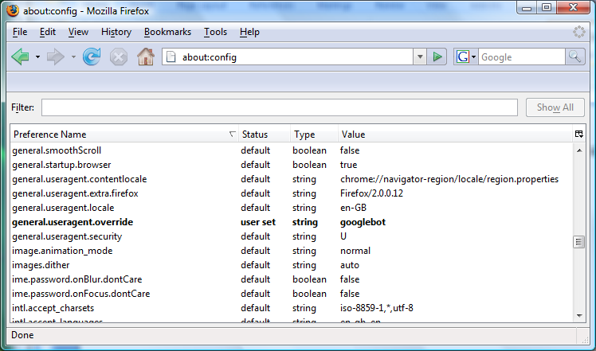

Your Firefox browser is now issuing a user agent string as if it where Google’s crawler, called ‘Googlebot’. Browsing the catalogSitemap.xml or any other part of a Blueprint-site will now show you how Google is seeing your site.

NOTE: If the URL’s displayed don’t appear to be the SEO-friendly variety, try setting the ‘general.useragent.override’ property to ‘vspider’. If everything then looks OK when you try it, it is likely that your Robot.properties file needs to be updated with a newer list of robots that includes ‘googlebot’. Try this one:

Registering you Site Index (Google)
Google provides a set of ‘Webmaster Tools’ which allow business to manage and influence how Google crawls and indexes your site.
You need to add you site URL to into the Webmaster Tools at:
https://www.google.com/webmasters/tools/siteoverview

Having registered your site, you can its Site Overview:
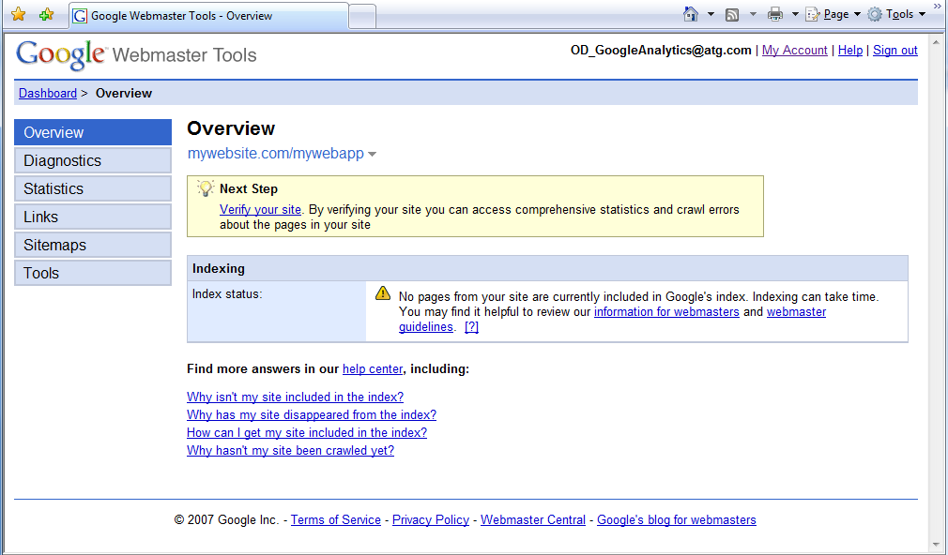
Once Google has indexed your site, you will be able to see all sorts of information and statistics regarding how Google. You may find that Google already has information, or it may take a couple of weeks to show up.

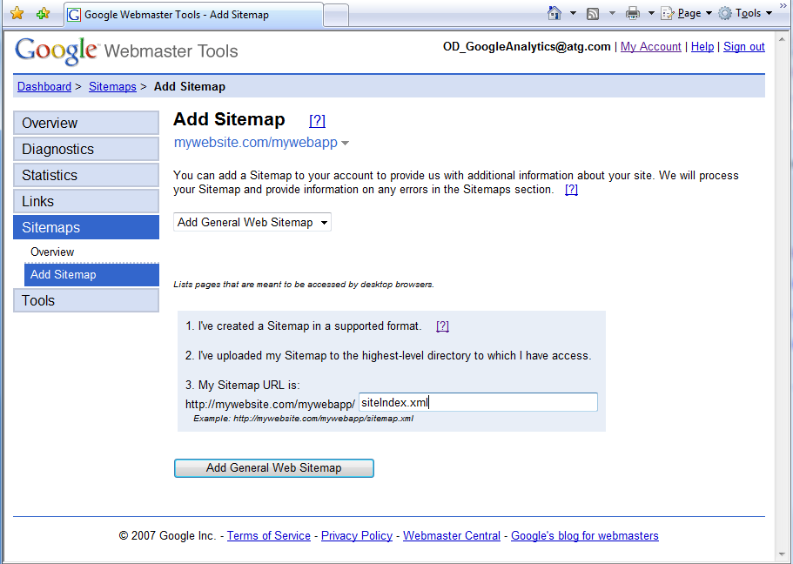
Clicking on the ‘Sitemaps’ section will allow you to add a new sitemap.

NOTE: The name of the sitemap file you enter should be your Site Index file; ‘sitemap.jsp’.
(I incorrectly typed siteIndex.xml in the screenshot ;-)

Having registered your sitemap.jsp, you should be able to check back at a later date, and confirm that Google is now using your file to help index your site.
NOTE: Google may complain about the white space that it sees at the top of the rendered JSP, but it will process the file regardless. You may choose to use JBoss’s white space trimmer option to help this.

